**Heuristic Evaluation for nba.com/pacers**

Date of Report: November 4, 2016

Date of Review: November 4, 2016 Reviewers: Josh Lane, Web Developer

Prepared for: N285

**Table of Contents**

*Heuristic Evaluation for nba.com/pacers*

*Table of Contents 1-2*

*Executive Summary 2*

*Explanation of Findings Table 2-3*

*Detailed Findings*

*Finding 1: Advertisement Placement 4*

*Finding 2: Search Bar 5*

*Finding 3: Hidden Navigation Bar 6*

*Finding 4: Unclear Charta Data Titles 7*

*Finding 5: Text Placement in Footer 8*

*Finding 6:* *Video Description Text Cut-off 9*

*Finding 7:* *Numerous Links to New Pages 10*

*Finding 8:* *Evidence of an older Web page style 11*

*Finding 9:* *Images loading 12*

*Finding 10:* *Search Keywords 13*

*Finding 11: No Back Button on New Sites 14*

*Finding 12: Navigation Link Names Unclear 15*

*Finding 13: Live Chat Button 16*

*Finding 14:* *Email Us 17*

*Finding 15:* **Navigation Bar is Broken** *18*

**Executive Summary**

IUPUI student Josh Lane conducted a heuristic evaluation on nba.com/pacers, the Indianapolis Pacers website. He used Nielsen’s 10 heuristics, noting potential issues based on his experience.

Overall, the review the site is very good it has a lot of content that could be left and small fixes here and there but nicely done overall.

See the Detailed Findings by Item section for further details.

**Explanation of Findings Table**

Heuristic: Nielsen’s 10 heuristics, <http://www.useit.com/papers/heuristic/heuristic_list.html>

**Visibility of system status**

The system should always keep users informed about what is going on, through appropriate feedback within reasonable time.

**Match between system and the real world**

The system should speak the users' language, with words, phrases and concepts familiar to the user, rather than system-oriented terms. Follow real-world conventions, making information appear in a natural and logical order.

**User control and freedom**

Users often choose system functions by mistake and will need a clearly marked "emergency exit" to leave the unwanted state without having to go through an extended dialogue. Support undo and redo.

**Consistency and standards**

Users should not have to wonder whether different words, situations, or actions mean the same thing. Follow platform conventions.

**Error prevention**

Even better than good error messages is a careful design which prevents a problem from occurring in the first place. Either eliminate error-prone conditions or check for them and present users with a confirmation option before they commit to the action.

**Recognition rather than recall**

Minimize the user's memory load by making objects, actions, and options visible. The user should not have to remember information from one part of the dialogue to another. Instructions for use of the system should be visible or easily retrievable whenever appropriate.

**Flexibility and efficiency of use**

Accelerators -- unseen by the novice user -- may often speed up the interaction for the expert user such that the system can cater to both inexperienced and experienced users. Allow users to tailor frequent actions.

**Aesthetic and minimalist design**

Dialogues should not contain information which is irrelevant or rarely needed. Every extra unit of information in a dialogue competes with the relevant units of information and diminishes their relative visibility.

**Help users recognize, diagnose, and recover from errors**

Error messages should be expressed in plain language (no codes), precisely indicate the problem, and constructively suggest a solution.

**Help and documentation**

Even though it is better if the system can be used without documentation, it may be necessary to provide help and documentation. Any such information should be easy to search, focused on the user's task, list concrete steps to be carried out, and not be too large.

*Feedback/Issue:* Explain the reasons why the interface violates or upholds this heuristic. Be sure to be clear about where in the screen you are referencing.

*Screen/Scope:* Describe the scope of the feedback or the problem; include whether the scope of the issue is throughout the product or within a specific screen or screens. If the problems are specific to a page, include the appropriate page numbers.

*Severity (H/M/L):* Your assessment as to whether the implication of the feedback is low, medium, or high severity.

*Solutions / Trade-offs:* Suggestion for the modifications that might be made to the user interface to address the issue or issues in this row. You MUST include trade-offs to be credible. If you can’t think of some bad trade-off, say so.

**Detailed Findings**

**Finding 1: Advertisement Placement**

|  |  |
| --- | --- |
| **Heuristic** | Consistency and standards |
| **Feedback / Issues** | Advertisements are randomly placed around the news feed every time the user selects view more new advertisements appear randomly throughout. |
| **Screen / Scope** | The news section of the home page |
| **Severity** | Low |
| **Solutions and Trade-offs** | Place advertisements in the new section in the same position throughout do not randomly through them in. |
| **Screen Captures** | See below |

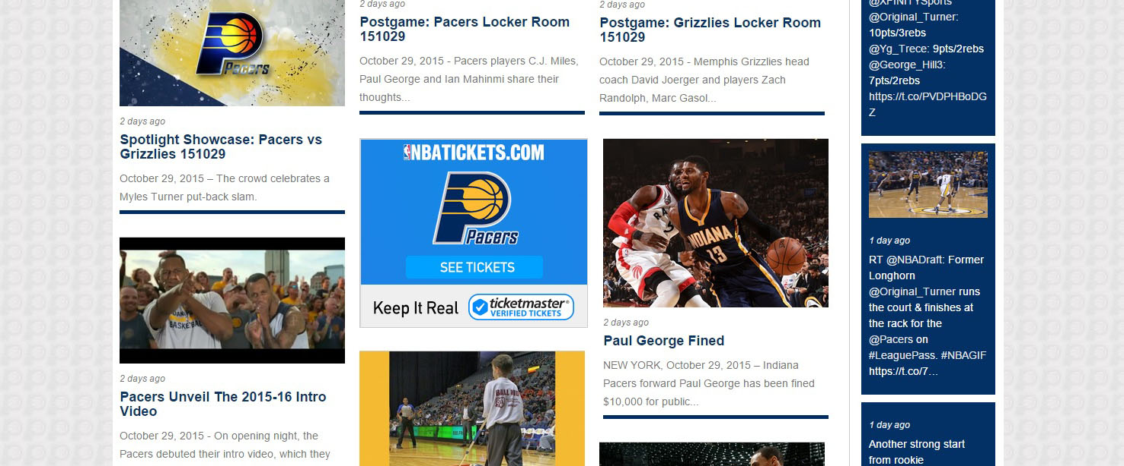

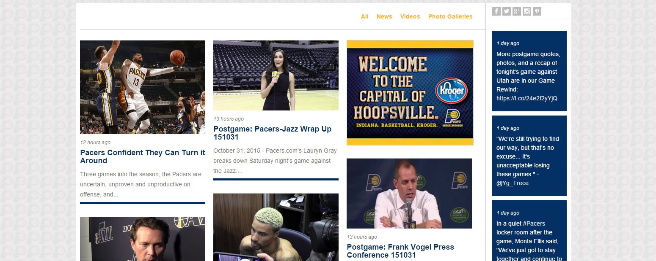

|  |  |
| --- | --- |
| **Heuristic** | Flexibility and efficiency of use |
| **Feedback / Issues** | When you hover your mouse over the word search the bar freaks out and can’t decide whether to become a text field or stay how it is. |
| **Screen / Scope** | Navigation Bar at the top of the page |
| **Severity** | Low |
| **Solutions and Trade-offs** | Fix it one of two ways make the word search where the text field won’t display when the mouse hovers over it or just have the search bar present by default. |
| **Screen Captures** | See below |

**Finding 2: Search Bar**



|  |  |
| --- | --- |
| **Heuristic** | Visibility of system status |
| **Feedback / Issues** | The navigation bar is fixed to the top of the page but the color of the navigation bar is the same color as the majority of the subject areas so it blends in and is hard to notice at points |
| **Screen / Scope** | Just below the featured content of the home page |
| **Severity** | Low |
| **Solutions and Trade-offs** | Change color of navigation bar to have clearly seen |
| **Screen Captures** | See below |

**Finding 3: Hidden Navigation Bar**

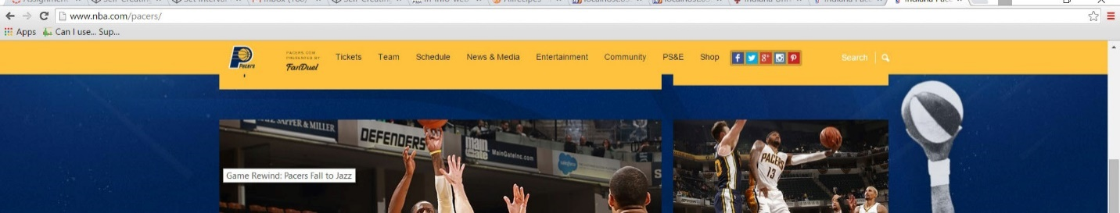

|  |  |
| --- | --- |
| **Heuristic** | Flexibility and efficiency of use |
| **Feedback / Issues** | Titles in the graph are abbreviated and the graph doesn’t have a key to allow new users to know what is being graphed. Designer is already assuming we know what is being graphed. |
| **Screen / Scope** | Top of the home page in game info graph section |
| **Severity** | low |
| **Solutions and Trade-offs** | Add a key or explain what is being graphed |
| **Screen Captures** | See below |

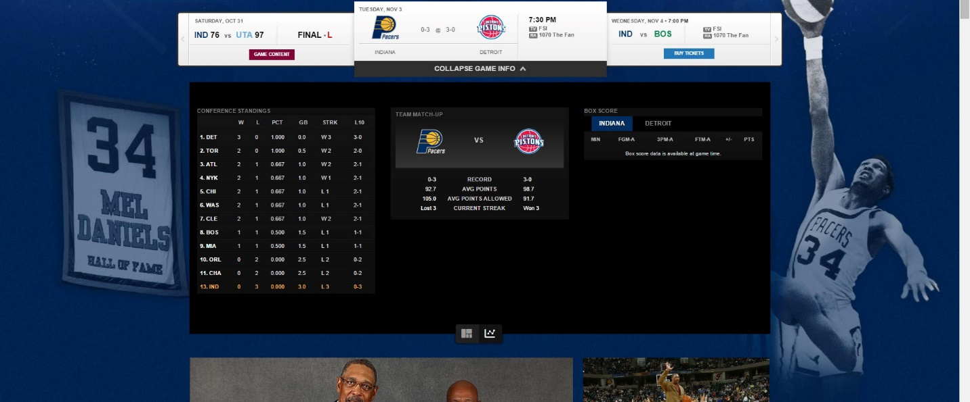**Finding 4: Unclear Charta Data Titles**

|  |  |
| --- | --- |
| **Heuristic** | Consistency and standards |
| **Feedback / Issues** | The text in the footer are placed in a strange way two of the columns of links are aligned bottom while the rest are aligned top |
| **Screen / Scope** | In the footer of the home page |
| **Severity** | low |
| **Solutions and Trade-offs** | Align all text top or bottom |
| **Screen Captures** | See below |

**Finding 5: Text Placement in Footer**

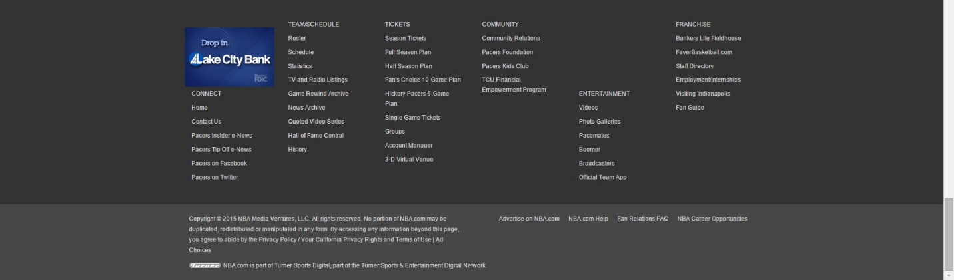

|  |  |
| --- | --- |
| **Heuristic** | Consistency and standards |
| **Feedback / Issues** | Text description in the video section of the home page is cut off slightly |
| **Screen / Scope** | Description in the video section of the home page |
| **Severity** | low |
| **Solutions and Trade-offs** | Increase margins of the video section |
| **Screen Captures** | See below |

**Finding 6: Video Description Text Cut-off**

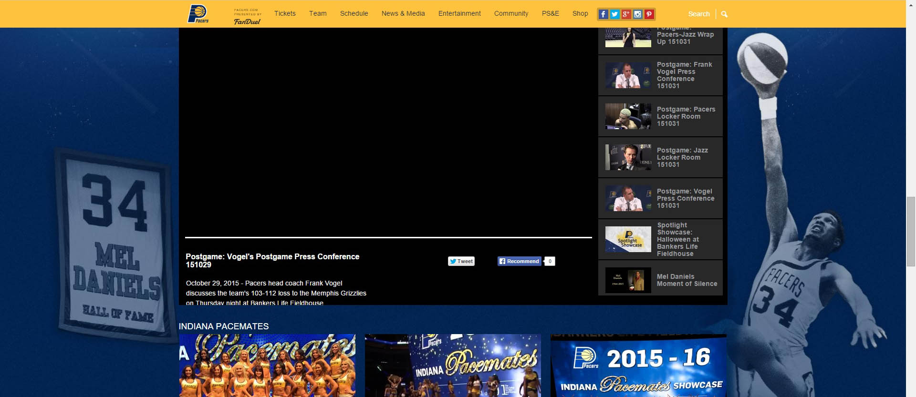

|  |  |
| --- | --- |
| **Heuristic** | Aesthetic and minimalist design |
| **Feedback / Issues** | There are many links in the navigation bar that open up new tabs or take you away from the actual pacers website to pages like the pacers foundation, pace mates cheerleader’s home page and so on. |
| **Screen / Scope** | Throughout navigation bar |
| **Severity** | low |
| **Solutions and Trade-offs** | Having so many links to different websites is distracting and it presents too much information. Keep information regarding anything pacers on the pacers website and everything else have it open a new tab on a new home page so users no okay this is not the same website anymore. |
| **Screen Captures** | N/A |

**Finding 7: Numerous Links to New Pages**

|  |  |
| --- | --- |
| **Heuristic** | Consistency and standards  Aesthetic and minimalist design |
| **Feedback / Issues** | If you click game rewind archive and any year before 2013 you can view all of the information how it was written in the same format it was written on a different older form of the web site it does not fit the style of their new website. It feels as if they forgot about it or got lazy and didn’t finish it. |
| **Screen / Scope** | Game rewind archive any year before 2013 |
| **Severity** | Low-medium |
| **Solutions and Trade-offs** | Give the entirety of the website the same theme, color scheme, or style. |
| **Screen Captures** | N/A |

**Finding 8: Evidence of an older Web page style**

|  |  |
| --- | --- |
| **Heuristic** | Visibility of system status |
| **Feedback / Issues** | Many of the images throughout the site take way too long to load. |
| **Screen / Scope** | Throughout site |
| **Severity** | Low-medium |
| **Solutions and Trade-offs** | Optimize images to help reduce the time it takes load in the images or use AJAX techniques when you are changing only sections of the site to help save loading time. |
| **Screen Captures** | N/A |

**Finding 9: Images loading**

|  |  |
| --- | --- |
| **Heuristic** | Help and documentation |
| **Feedback / Issues** | The search keywords only work for some players and some coaches. You can type anything that has to do with the pacers and you will get one or maybe two results and the rest will be about players and coaches |
| **Screen / Scope** | Search bar and search results |
| **Severity** | low |
| **Solutions and Trade-offs** | Increase the key words available for the site it is confusing slightly when you have options available that you can type but can’t see the name for it pop up in the suggestion box |
| **Screen Captures** | N/A |

**Finding 10: Search Keywords**

|  |  |
| --- | --- |
| **Heuristic** | User control and freedom |
| **Feedback / Issues** | When users click on a link that navigates to a new website there is no button to go back to the other website |
| **Screen / Scope** | Throughout navigation bar |
| **Severity** | low |
| **Solutions and Trade-offs** | Add a way to navigate back to the main site on external pages |
| **Screen Captures** | N/A |

**Finding 11: No Back Button on New Sites**

|  |  |
| --- | --- |
| **Heuristic** | Help and documentation  Match between system and the real world |
| **Feedback / Issues** | In the navigation bar the PS&E doesn’t have a universal meaning so not enough people understand what that means for them to have this abbreviated. |
| **Screen / Scope** | Navigation bar |
| **Severity** | low |
| **Solutions and Trade-offs** | Write out the full name of the abbreviation to avoid confusion |
| **Screen Captures** | See below |

**Finding 12: Navigation Link Names Unclear**



|  |  |
| --- | --- |
| **Heuristic** | Consistency and standards |
| **Feedback / Issues** | When you click on ticket then two for Tuesday. The live chat button doesn’t work it doesn’t connect to anything |
| **Screen / Scope** | Two for Tuesday live chat button |
| **Severity** | low |
| **Solutions and Trade-offs** | Make a chat page to link to the button on click. |
| **Screen Captures** | See below |

**Finding 13: Live Chat Button**

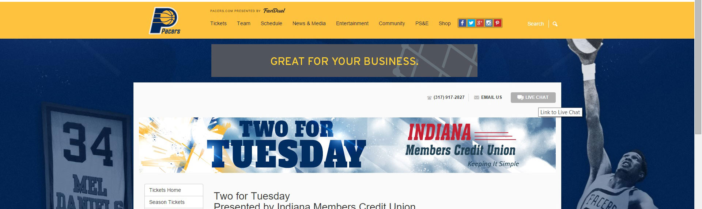

|  |  |
| --- | --- |
| **Heuristic** | Consistency and standards  Visibility of system status |
| **Feedback / Issues** | Whenever you click on the Email Us button in the two for Tuesday section the link doesn’t work and it doesn’t show anything to say it’s working or not working |
| **Screen / Scope** | Two for Tuesday Email Us button |
| **Severity** | low |
| **Solutions and Trade-offs** | Add a page for the email us to send to, so the user can send emails to you. |
| **Screen Captures** | See below |

**Finding 14: Email Us**



|  |  |
| --- | --- |
| **Heuristic** | Consistency and standards |
| **Feedback / Issues** | If you click on the PS&E careers/internships button, the navigation bar there is broken in the sense that it doesn’t have the same styles as the rest of the site and the drop down menus overflow on top of the text |
| **Screen / Scope** | PS&E careers/internships page in the navigation bar |
| **Severity** | low |
| **Solutions and Trade-offs** | Apply the same styles for the navigation bar that the rest of the site has. Also make it so the drop down menu doesn’t flow on top of the rest of the pages content. |
| **Screen Captures** | See below |

**Finding 15: Navigation Bar is Broken**

